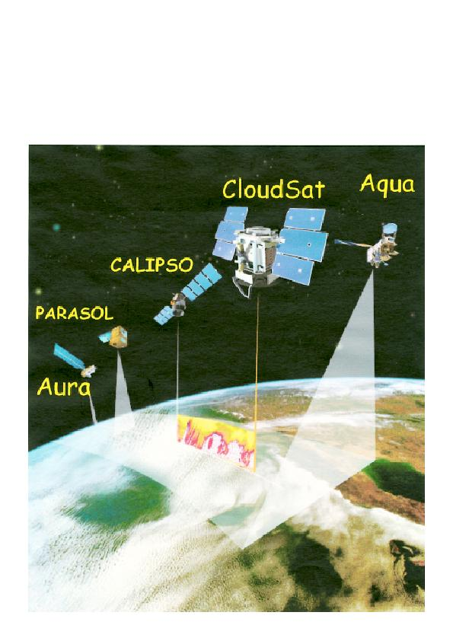

CloudSat
In April 2005, NASA will launch a JPL- Colorado State cloud-mapping experiment called CloudSat. In a near-polar orbit at 705 km altitude with a 99-minute period, CloudSat will carry a pulsed, 1.8 kW, narrow-band, 94.05 GHz radar feeding a nadir-pointing (downward-looking), high-gain, off-axis parabolic antenna. This global mapping experiment, part of NASA's "A-Train" (pictured), will fly overhead, or very nearly so, at a substantial fraction of the world's observatories: just which ones are overflown during a given few-week period will change slightly with time and will only be known after launch.
Power levels of the CloudSat radar are such that an SiS-junction deployed on a typical radio telescope could be burned out if the telescope is pointing at the zenith during an overflight. Moreover, an SiS receiver will probably saturate during an overflight (or near overflight) no matter where the radio telescope is pointed, and similarly-strong signal levels would be received if a telescope points at or near CloudSat whenever the satellite is above the horizon (which could be of order one hour per day at a typical location). The narrow-band, Doppler-shifted radar signal will probably be detectable in even fairly short integrations no matter where a radio telescope is pointed, whenever CloudSat is above the horizon.

How did this happen and what can I do about it?
Regulatory permission to use systems like CloudSat was granted at the 1997 World Radio Conference (WRC97) after much discussion between the Earth-sensing and astronomy representatives. The former wanted to use 1 GHz of the spectrum, rather than the 100 MHz they were finally granted; astronomers pressed unsuccessfully to lower the frequency of operation below 80 GHz. The following is the text of two footnotes in the table of frequency allocations which govern the use of this small slice of the spectrum in the middle of the radio astronomy bands:
5.562--The use of the band 94-94.1 GHz by the Earth exploration-satellite (active) and space research (active) services is limited to spaceborne cloud radars.
5.562A--In the bands 94-94.1 GHz and 130-134 GHz, transmissions from space stations of the Earth exploration-satellite service (active) that are directed into the main beam of a radio astronomy antenna have the potential to damage some radio astronomy receivers. Space agencies operating the transmitters and the radio astronomy stations concerned should mutually plan their operations so as to avoid such occurrences to the maximum extent possible.
Why am I only finding out about this now?
As may be seen in footnote 5.562A, permission was granted contingent on mutual planning with radio astronomy. Unfortunately, the radio astronomy community remained unaware until it was approached by the CloudSat project team in 2004 July. Shortly thereafter, acting on behalf of the worldwide radio astronomy community, IUCAF brought its concerns to the attention of the annual Space Frequency Coordination Group (SFCG) meeting in September 2004, which adopted SFCG Resolution 24-2 on this issue (see the blue text box at the bottom of this page).
What should my observatory do in response to CloudSat?
The radar cannot be turned off when it flies overhead, and can cause problems for observing even when far from the zenith. Therefore, each observatory will have to formulate a response to the presence of CloudSat which is contingent on its particular observing practices, the characteristics of its electronics, geographic location, and so forth. At the very least, it is probably unwise to park mm-wave telescopes near the zenith while CloudSat is operating. But first it will be necessary to acquire some familiarity with CloudSat's operating characteristics and the general properties of its orbit. This web site is designed to provide enough information to get a good start with these things.
Where can I go for the information needed to protect my telescope?
Detailed pre-launch specs provided by JPL for the CloudSat radar are given in the link at left called "JPL Technical Info" and a technically-informed discussion of CloudSat's impact on ALMA is contained in the ALMA memo 504 linked just below that. This document should serve as a template for understanding CloudSat in the radio-astronomical context. It also contains some illustrative examples of CloudSat's orbit characteristics, based on the orbital elements of the A-train formation of satellites -- already up -- with which it will fly. The CloudSat home page linked at the top of this website also contains information on CloudSat.
But what about the orbit? How directly will my observatory be affected?
JPL ran some simulations based on the A-train orbit which, as it applies in 0-order to CloudSat now, repeats on a 16 day cycle; in actuality, atmospheric drag will cause 10 km horizontal differences which will evolve over the course of the mission, necessitating constant updating of the orbital elements. After launch, CloudSat will fly somewhat off to the side of the main body of the A-train -- of order ~210 km . Any guesses why?
The simulations were meant to be representative, not definitive, and results are shown here. Sites highlighted in red were overflown within 15 km during the single, repeating, simulated 16 day cycle and so considered -- in this context -- almost certain to have an overflight (because of the deltas introduced by atmospheric drag) while other sites were overflown within 30 km or more distance, and are less likely to have a direct overflight. As may be seen, most observatories may expect to suffer overflights -- it is after all a global mapping experiment, see Figure 2 of the ALMA memo -- and all will suffer the effects noted above here and in the linked info.
How do I get detailed orbit information for myself and my site?
JPL is creating a web-based tool which for a given location on the earth will calculate accurate current and near-term orbital positions (az, el. etc. vs. time). As of the end of November 2004 this has not yet been made available. However, when implemented it will recognize a list of sites so that coordinates need not be entered repeatedly. For now, you might check here or on the list of telescopes at left to see whether your site has been included already. If so, please check the coordinates. If not, please contact JPL.
For those who wish to roll their own orbit calculations, there are many programs available that use a satellite's Keplerian elements to calculate its precise position as seen from a given location. Nearly all of these programs accept the orbital elements in the form of publicly-available "Two Line Element sets" (TLE). For a variety of reasons the orbit varies unpredictably with time; for the most precise predictions, the TLE data need to be no older than one or two days. For very approximate calculations a month-old TLE set may still be somewhat useful - JPL says that the error in CloudSat predictions in this case may be up to 45 seconds of time, which could represent tens of degrees of Az-el. It is anticipated that the TLE for CloudSat will be available from Celestrak, under "NORAD Two-Line Element Sets, Current Data," "Weather and Earth Resource Satellites, Earth Resources" -- i.e. here. This site is currently updated at least daily, but the URL and free access may change in future. It is hoped also that JPL will provide astronomers with updated elements.
Of the many satellite orbit prediction programs available, some are very precise but others are extremely poor. One of the most precise is "TrakStar" which is available from the Celestrak web site; for an index to this and many other programs, including in some cases source code, click here or follow the celestrak links at the left side of this page.
Coming up to speed quickly on a PDA
Integrated satellite tracking/visualization tools are available for handheld devices at the PocketSat+ web site cited at left. On a Tungsten E, this code (once registered for $25) required less than two minutes to find all the tracks where AQUA rose above 3d at the ALMA site over a 16-day period. It uses the usual TLE, current versions of which are kept available in .pdb format, and plots passes or satellite positions in real or accelerated time.
Future cloud-mapping projects Experiments like CloudSat will in fact probably fly regularly from now on. Although the formal lifetime of CloudSat is ~ 20 months (the project personnel of course hope it extends much longer) a similar but more powerful mission is slated for launch in 2012 by ESA. | Coordination with radio astronomy An agreement has been crafted between IUCAF and the Space Frequency Coordination Group (SFCG) obliging the earth-sensing and radio astronomy communities to remain in closer contact. The last-minute arrangements which characterized the CloudSat-radio astronomy interaction should be precluded.
About Us || Privacy Policy | Contact Us | ©2004 NRAO

