Annual Report for 2020

IUCAF

THE SCIENTIFIC COMMITTEE ON FREQUENCY ALLOCATIONS
FOR RADIO ASTRONOMY AND SPACE SCIENCE
(IAU - URSI - COSPAR)

- INTRODUCTION

The Scientific Committee on Frequency Allocations for Radio Astronomy and Space Science, IUCAF, was formed in 1960 by its adhering Scientific Unions, IAU, URSI, and COSPAR at the behest of URSI. The IUCAF brief is to study and coordinate the requirements of radio frequency spectrum allocations for passive radio sciences – radio astronomy, space research and remote sensing – and to make these requirements known to the national and international bodies that regulate the use of the radio spectrum.

IUCAF operates as an Inter-Disciplinary Body under the auspices of the International Science Council (ISC, formerly ICS and ICSU). IUCAF is a Sector Member of the International Telecommunication Union’s Radiocommunication Sector (ITU-R) with observer status at the Space Frequency Coordination Group (SFCG). IUCAF celebrated the 60th anniversary of its founding in 2020. IUCAF is online at http://www.iucaf.org.

- MEMBERSHIP AND MEMBER AFFILIATIONS WITH OTHER BODIES

There was no change to the composition of IUCAF during 2020, and IUCAF is still seeking a replacement IAU committee member for one who resigned in 2018. At the end of 2020 the IUCAF membership from the three adhering Unions was:

URSI: | Dr. Haiyan Zhang | China
 | Dr. Steven Reising | USA
 | Dr. Ingemar Häggström | Sweden
 | Dr. Anastasios Tzioumis | Australia
 | Dr. Wim van Driel | France
IAU: | Dr. Harvey Liszt (Chair) | USA
 | Dr. Masatoshi Ohishi | Japan
 | Dr. Adrian Tiplady | South Africa
COSPAR: | Dr. Yasuhiro Murata | Japan

Additionally, the Counselor for ITU-R Study Group 7 (Science Services), Mr. Vadim Nozdrin, is a member ex-officio by virtue of his ITU-R position, as specified in IUCAF’s Terms of Reference. IUCAF also has an informal group of correspondents, in order to improve its global geographic representation and for consultation on specific issues, for instance concerning astronomical observations in the optical and infrared domains.

IUCAF members also participate in the activities of other bodies. Tiplady is a member of CRAF, the European Committee on Radio Astronomy Frequencies of the European Science Foundation (https://www.craf.eu/). Zhang is Chair of the Radio Astronomy Frequency Committee in the Asia-Pacific region (RAFCAP) whose members also include Ohishi and Tzioumis (see http://www.atnf.csiro.au/rafcap/). Tzioumis is Chair of ITU-R Working Party 7D (Radio Astronomy). Ohishi, IUCAF’s Immediate Past Chair, is the official liaison between the IAU and the ITU and President of IAU Commission F3 (Astrobiology), and is Head of the newly-created Spectrum Management Office at the National Astronomical Observatory of Japan. Van Driel was until recently the Secretary of IAU Commission B4 on Radio Astronomy and a member of its Organizing Committee. Liszt is a member of the American Astronomical Society’s Committee on Light Pollution, Radio Interference and Space Debris and the IAU Executive Committee on WG Dark and Quiet Sky Protection, and serves on the Steering Committee of the IAU Inter-Division Commission C.B4 on Protection of Existing and Potential Observatory Sites.

- IUCAF TERMS OF REFERENCE (Revised 2015)

A revision to the statement of IUCAF’s composition, operating practices and Terms of Reference (TOR), originally dating to 1972 when IUCAF was the Inter-Union Committee on Allocation of Frequencies, was approved by ICSU’s Executive Board in 2015, see http://www.iucaf.org/IUCAF_Terms_Of_Reference.pdf.

- INTERNATIONAL & REGIONAL SPECTRUM MANAGEMENT MEETINGS ATTENDED BY IUCAF MEMBERS DURING 2020

Most radio frequency spectrum management meetings were moved online during 2020. IUCAF members participated in the following international and regional regulatory meetings:

04/17-04/21 | Working Party 7C | ITU-R
05/06 | Committee on Radio Astronomy Frequencies – CRAF | ESF
05/07-05/08 | Committee on Radio Frequencies – CORF | US NAS
05/28-05/29 | Working Party 4A, 4C | ITU-R
06/23-07/09 | Working Party 5D | ITU-R
07/20-07/30 | Working Party 5A,5B,5C | ITU-R
09/14-09/18 | Working Party 7D | ITU-R
09/28-10/02 | Working Party 7C | ITU-R
10/05-10/16 | Working Party 5D | ITU-R
10/21-10/27 | Working Party 4C | ITU-R
10/28-11/05 | Working Party 4A | ITU-R
11/24-12/02 | Working Party 1A | ITU-R
11/31-12/01 | Committee on Radio Astronomy Frequencies - CRAF | ESF

Despite the large number of ITU-R meetings, work as usual began somewhat tentatively at the start of the ITU-R work cycle directed toward completion of the Agenda for WRC-23 in November 2023. Characteristics were not immediately available for study of the radiocommunication systems whose needs are to be considered, and initial organizational work had to be cleared. IUCAF submitted one ITU-R document, revising Recommendation ITU-R RA.1031 to make clear that it applies only to bands shared between radio astronomy and active services.

Members also participated in national spectrum management proceedings, working in their capacities as spectrum managers at their respective observatories.

IUCAF BUSINESS MEETINGS

IUCAF met in-person during the Fifth International School described below. During the remainder of the year, IUCAF business was undertaken via email as matters arose.

FINANCES

The IUCAF budget is held and managed by URSI. Sustaining financial contributions of €5,000, €2,000 and €1,000 were gratefully received from IAU, URSI, and COSPAR, respectively, for calendar year 2020. Expenses of €8800 were incurred in relation to the 5th International IUCAF Spectrum Management School that is described below.

THE IUCAF ROLE – A NEW COORDINATION AGREEMENT WITH ESA

IUCAF is a global forum where spectrum management concerns of passive radio science in all ITU-R Regions are regularly addressed in a comprehensive manner. The group is expert in the underlying science, in the spectrum management needs of the science and in the workings of the spectrum regulatory regime that allocates spectrum and makes the rules for radio spectrum use. IUCAF has supported radio astronomy and passive radio science in Geneva since its inception in 1960 when the first spectrum band was allocated for exclusive use by passive research.

IUCAF’s 60th birthday passed little noticed in 2020, but several IUCAF members are even older. IUCAF’s early history is recounted by former Chair Dr. Brian Robinson in “Frequency Allocation: The First Forty Years,” Annual Reviews of Astronomy and Astrophysics, 1999, vol. 37, pp 65-96, available at https://tinyurl.com/y5vsgb6x.

The practice of reserving narrow portions of the radio frequency spectrum for passive radio science expanded after 1960 to the extent that bands shared by radio astronomy and satellite remote sensing now provide crucial information used to improve weather forecasting and to quantify the effects of climate change. On this basis, IUCAF also provides an interface between the radio astronomy and satellite remote sensing communities through participation at the Space Frequency Coordination Group. This participation led to the initial drafting of an agreement between IUCAF and the European Space Agency whereby the 94.05 GHz cloud profiling radar on ESA’s forthcoming flagship Earthcare mission will not directly illuminate radio telescopes, removing the potential for damaging radio astronomy receivers pointed near the local zenith during a satellite overpass.

CONTACT WITH ICS, THE IUCAF SPONSORING UNIONS (IAU, URSI, COSPAR) AND OTHER INTERNATIONAL ORGANIZATIONS

IUCAF maintains regular contact with its adhering Unions and the parent body ISC. These organizations play a strong supporting role for IUCAF, whose members are greatly encouraged thereby.

A major international Workshop on Dark and Quiet Skies for Science and Society (http://research.iac.es/congreso/quietdarksky2020) was organized online 5-9 October 2020 by the IAU, UN Office of Outer Space Affairs and the Instituto de Astrofisica de Canarias where the workshop was originally intended to occur. Some 1000 registrants attended online in numbers of approximately 300 on each of five days. The IUCAF Chair represented radio astronomy on the Scientific Organizing Committee, which convened five working groups to report on aspects of protection of the sky and spectrum, including biohazards of light illumination. IUCAF members comprised half of the radio astronomy working group and a small portion of the much larger satellite working group that was concerned with impacts to optical astronomy.

The workshop produced a long-form compilation of the five highly-technical working group reports and a ‘Conference Room Paper’ for the April 2021 meeting of the Scientific and Technical Subcommittee of UNOOSA’s Committee On Peaceful Uses of Outer Space, COPUOS (https://www.iau.org/news/announcements/detail/ann21002/)

This was of special importance to IUCAF and radio astronomy because it occurred internationally and outside the usual regulatory regime that protects only the small amount of spectrum that is formally allocated to astronomy. The meeting considered risks to radio astronomy of all kinds across the spectrum and concluded that satellites in low earth orbit should refrain from illuminating radio telescopes and radio quiet zones, with specific recommendations to accomplish this goal.

OUTREACH, TRAINING AND THE FIFTH INTERNATIONAL IUCAF SCHOOL ON SPECTRUM MANAGEMENT FOR RADIO ASTRONOMY

IUCAF maintains its World Map of Radio Astronomy Sites and Radio Quiet Zones that has been viewed 61,800 times since its creation in 2008, see http://tinyurl.com/yrvszk. IUCAF continued to distribute its exceptionally popular IUCAF-logo fidget-spinner that was pictured last year, thanks to a continuing grant from an anonymous donor.

IUCAF’s main outreach activities are the international spectrum management schools it organized in 2000, 2005, 2010 and 2014. These events are necessary to maintaining a knowledge base for spectrum management inside radio astronomy, and for acquainting spectrum regulators with the very particular concerns of radio astronomy.

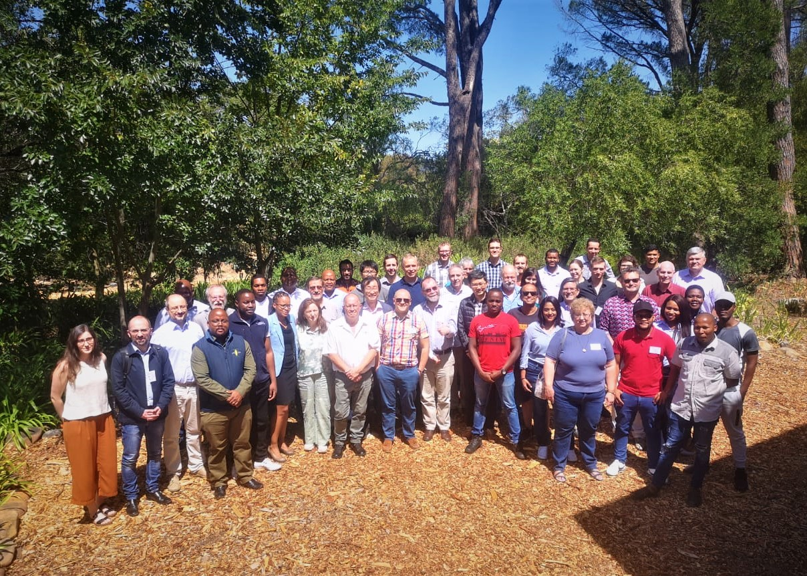

Through a magnificent stroke of good luck, the Fifth IUCAF International School on Spectrum Management took place in Stellenbosch, South Africa during the period 2-6 March 2020, shortly before the world shut down. This meeting could not have occurred or been so successful without the strong financial and logistical support of the South African Radio Astronomy Observatory, SARAO, and a substantial financial subvention of European participation on the part of CRAF. Owing to this generosity and in respect of the venue, the meeting was held without fees for registration and meals, including the traditional banquet, and participants were provided with a spectrum management textbook written by one of the non-IUCAF lecturers. The attendance of 55 participants was far larger than usual.

Presentations from this and the previous IUCAF schools are available on the IUCAF website at http://www.iucaf.org.

- IUCAF CONCERNS IN 2020 AND BEYOND

Until recently, improved access to spectrum for science ran through the radio frequency spectrum regulatory regime, by procuring and protecting allocated spectrum. But the tables have turned: allocations to science are fixed while the rest of the spectrum fills in with new radiocommunication systems. Radio astronomy will increasingly find clean spectrum only with strong radiocommunication signals in the same passband. There are a variety of unintended and undesirable consequences from these new systems, not only for radioastronomy. Adequate limits are not always placed on their unwanted emissions into bands intended for science, especially 5G near 24 GHz. Earth-mapping synthetic aperture radar (SAR) satellites at L-, C- and X-band can burn out radio astronomy receivers. Satellite trails from reflected sunlight are increasingly affecting (“photo-bombing”) optical/infrared astronomy, even from the Hubble Space Telescope. It was just such considerations, and the inability to raise them at ITU-R, that motivated such strong IUCAF involvement in the October 2020 Dark and Quiet Skies Workshop.

Closer to home, succession planning and matters of engagement continue to be of concern. Several nations with major investments in radio astronomy and/or strong histories of participation are not currently represented by astronomers in spectrum management despite IUCAF prodding.

- ACKNOWLEDGEMENTS

IUCAF is grateful for the organizational and financial support that has been given by ICS, IAU, URSI and COSPAR over the past 60 years, especially the URSI secretariat. IUCAF also recognizes the support given by radio astronomy observatories, universities and national funding agencies to individual IUCAF members, allowing them to participate in the vital work of the committee. IUCAF especially appreciates the contributions of the organizations and individuals who made the spectrum management school such a resounding success in March 2020, as the world was about to shut down.

Respectfully submitted,

Harvey Liszt, Chair

Charlottesville, Virginia, USA | IUCAF website: | http://www.iucaf.org
17 February 2021 | IUCAF contact: | iucafchair@iucaf.org

