Report To URSI Council 2021-2023

IUCAF

THE SCIENTIFIC COMMITTEE ON FREQUENCY ALLOCATIONS
FOR RADIO ASTRONOMY AND SPACE SCIENCE
(IAU - URSI – COSPAR and ISC)

- INTRODUCTION

IUCAF’s Annual Reports are published in the URSI Radio Science Bulletin; for 2021 see RSB #377 (June 2021). The as-yet unpublished Annual Report for 2022 can be found at
https://www.nrao.edu/~hliszt/RFI/IUCAF-AnnualReport2022.docx.

- ABOUT IUCAF

The Scientific Committee on Frequency Allocations for Radio Astronomy and Space Science, IUCAF, originally the Inter-Union Committee on Allocation of Frequencies, was formed in 1960 by its adhering Unions, IAU, URSI, and COSPAR at the behest of URSI under the aegis of ICSU. IUCAF is online at http://www.iucaf.org.

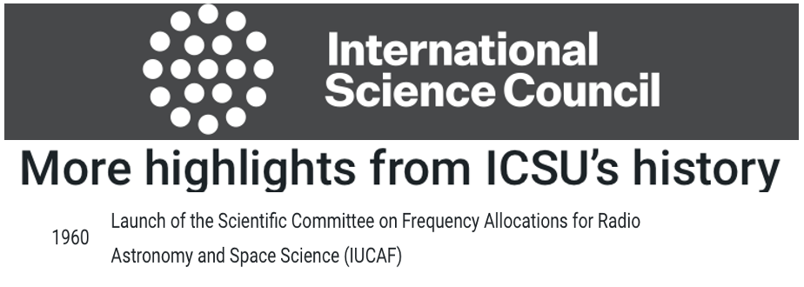
IUCAF now operates as an Affiliated Body under the auspices of the International Science Council. Its brief is to study and coordinate the requirements of radio frequency spectrum allocations for passive radio sciences (radio astronomy, space research and remote sensing) and to make these requirements known to national/international bodies that regulate use of radio spectrum. Its terms of reference, composition and operating practices can be found at http://www.iucaf.org/IUCAF_Terms_Of_Reference.pdf.

The IUCAF membership from the three adhering Unions is:

URSI: | Dr. Haiyan Zhang | China
 | Dr. Steven Reising | USA
 | Dr. Ingemar Häggström | Sweden
 | Dr. Anastasios Tzioumis | Australia
 | Dr. Wim van Driel | France
IAU: | Dr. Harvey Liszt (Chair) | USA
 | Dr. Masatoshi Ohishi | Japan
 | Dr. Adrian Tiplady | South Africa
COSPAR: | Dr. Yasuhiro Murata | Japan
Ex-officio | Dr. Vadim Nozdrin | ITU-R SG7

IUCAF is a Sector Member of the International Telecommunication Union’s Radiocommunication Sector (ITU-R) with observer status at the Space Frequency Coordination Group (SFCG) where it participates in the Lunar Martian Spectrum Group. IUCAF members participate in the activities of many other national and regional spectrum management bodies as noted in the Annual Reports.

- Preparation for the upcoming World Radiocommunication Conference WRC-23

IUCAF’s main ongoing activity since 1960 has been participation as a Sector Member at the ITU-R in Geneva. Owing to its long history, IUCAF’s efforts protecting radio astronomy and passive radio science are accorded a high degree of recognition.

IUCAF’s work was largely devoted to crafting protective regulatory text to be incorporated in the revised Radio Regulations at the upcoming World Radiocommunication Conference WRC-23 in Dubai. IUCAF provided 21 input contributions (technical studies and draft regulatory texts) to ITU-R, and attended or will attend numerous meetings to support them:

Spectrum regulatory meetings attended remotely in 2021
03/01-03/12 | Working Party 5D (IMT=Mobile Telecom) | ITU-R
04/12-04/16 | Working Party 7D (Radio Astronomy) | ITU-R
05/10-05/21 | Working Party 5B (Radar and airborne mobile) | ITU-R
05/20-05/21 | Committee on Radio Frequencies – CORF | US NAS
05/25-06/02 | Working Party 1A (Spectrum engineering) | ITU-R
06/07-06/18 | Working Party 5D | ITU-R
09/16-09/23 | Working Party 7D | ITU-R
10/04-10/15 | Working Party 5D | ITU-R
11/03-11/12 | Working Party 1A | ITU-R
11/29-12/10 | Working Party 5B | ITU-R
Spectrum regulatory meetings attended in 2022 (*=remote)
02/02-02/23* | Working Party 5D (IMT=Mobile Telecom) | ITU-R
03/29-04/08 | Working Party 5B (Radar/airborne mobile) | ITU-R
04/25-04/29 | Working Party 7D (Radio astronomy) | ITU-R
04/26-05/05 | Working Party 7B (Space research) | ITU-R
05/20-05/21* | Committee on Radio Frequencies | US NAS
06/13-06/24 | Working Party 5D | ITU-R
06/28-07/07* | Working Party 1A (Spectrum engineering) | ITU-R
07/11-07/22 | Working Party 5B | ITU-R
07/19-07/27 | Space Frequency Coordination Group | Australia
09/27-10/05 | Working Party 7B | ITU-R
09/28-10/05 | Working Party 7D | ITU-R
10/10-10/21 | Working Party 5D | ITU-R
11/14-11/25* | Working Party 5B | ITU-R
Spectrum regulatory meetings in 2023
03/27-04/07 | CPM23-2 (WRC-23 conference preparatory meeting) | ITU-R
05/30-06/07 | Space Frequency Coordination Group | Toulouse
06/12-06/23 | Working Party 5D (IMT=Mobile Telecom) | ITU-R
07/10-07/21 | Working Party 5B (Radar/airborne mobile) | ITU-R
10/03-10/10 | Working Party 7B | ITU-R
10/05-10/11 | Working Party 7D | ITU-R
11/13-11/17 | Radiocommunication Assembly | ITU-R Dubai
11/20-12/15 | WRC23 | ITU-R Dubai
12/18-12/19 | CPM27-1(WRC-27 conference preparatory meeting) | ITU-R Dubai
IUCAF’s views on WRC-23 Agenda items of concern to radio astronomy were submitted to the recent ITU-R CPM23-2 meeting (see above) and are independently available at http://www.cv.nrao.edu/~hliszt/RFI/IUCAF-Views-Rev1.docx. Of special concern and the subject of IUCAF’s studies were: Agenda Item 1.2 (IMT in the spectrum band 10-10.5 GHz); Agenda Item 1.4 (HIBS=IMT Base Stations on High Altitude Platforms); Agenda Item 1.10 (Wideband airborne data networks); and AI 1.13 (Space data relay satellite systems).

Accomplishing formal regulatory protection in the Radio Regulations – an international treaty that is revised through diplomacy every four years at the WRC – is a laborious and involved process. Items on the WRC agenda must be assessed for their potential impact by numerically modelling the deployment of the associated radiocommunication networks, based on characteristics provided at ITU-R that may be very unfamiliar to prospective victims of their operation. Modern radiocommunication systems are complex, using many frequency bands, equipment types (transmitters, antennas) and deployments in complex propagation environments. Once the impact of a radiocommunication system is understood, regulatory treaty text expressing constraints on the behavior of the implicated systems must be formulated and incorporated by consensus in the treaty text. Resolving differences between the proponents and victims of a new radiocommunication system can be contentious and drawn out over the entire 4-year study cycle between successive WRCs. Missing an ITU-R session or even a single argument can have serious negative consequences. The outcome of IUCAF’s work will not be understood until the final moments of WRC-23.

- Dark and Quiet Skies

As IUCAF noted in its 2017-2021 Report to Council, improved scientific access to new and existing spectrum has historically run through the radio frequency spectrum regulatory regime, by procuring and protecting spectrum allocations. But allocations to science have been static while the rest of the spectrum fills in with new radiocommunication systems using broad swaths of previously-allocated but unused spectrum. Adequate regulatory limits are not always placed on unwanted emissions from radiocommunication systems into bands intended for science.

Radio spectrum regulators have recently authorized constellations with satellites numbering in the tens to hundreds of thousands. The regulators are assiduously focused on protection of radio spectrum frequency allocations but have no remit to consider the external and environmental effects of such systems. The broadest consequences of large satellite constellations were the subject of two Dark and Quiet Skies for Science and Society meetings convened by the International Astronomical Union and the UN Office of Outer Space Affairs.

In an effort to better understand and make better understood the broader impact of radio spectrum regulatory processes, IUCAF members chaired the Radio Astronomy Working Groups at these meetings and participated in writing the Working Group Reports.

- ACKNOWLEDGEMENTS

IUCAF is grateful for the organizational and financial support that has been given by ICS, IAU, URSI and COSPAR, especially the URSI Secretariat that so efficiently and helpfully manages IUCAF’s finances and logistics. IUCAF also recognizes the support given to individual IUCAF members by their home institutions, allowing them to participate in the vital work of the committee.

Respectfully submitted,

Harvey S. Liszt, Chair
National Radio Astronomy Observatory
520 Edgemont Road
Charlottesville, Virginia USA 22903
iucafchair@iucaf.org

1 May 2023

Dark and Quiet Skies for Science and Society I and II: https://www.iau.org/news/announcements/detail/ann21002/ https://www.iau.org/news/announcements/detail/ann22002/

