The following is a summary of the outcomes of WRC-23 Agenda Items for issues where studies relating to radio astronomy were done, along with some adjacent topics and asides. The full outcome, including the Resolutions, Article 5 footnotes (fn) and other material cited here, is given in the publicly available Provisional Final Acts https://www.itu.int/wrc-23/ that use the usual temporary nomenclature until the 2024 Radio Regulations are published.

The issues are discussed in order of increasing frequency as one finds them while paging down through the Provisional Final Acts. None of the Agenda Items assigned to WP 5B or 5D produced publicly available ITU-R Reports, and a Report from WP 7B is not yet published, so references and links to background material buried in the document archives (as annexes attached to WP Chairman’s reports) are included at the end. TIES access is needed to retrieve these documents.

This post-mortem will be followed by a pre-mortem discussing the WRC-27 Agenda.

Enjoy, happy new year.

Harvey Liszt (hliszt@nrao.edu)

Agenda Item 1.12 to conduct, and complete in time for WRC-23, studies for a possible new secondary allocation to the Earth exploration-satellite (active) service for spaceborne radar sounders within the range of frequencies around 45 MHz, taking into account the protection of incumbent services, including in adjacent bands, in accordance with Resolution 656 (Rev. WRC-19)

This instance of the radar sounder is an adaptation of a device used around Mars that will be used around Europa and is likely to be used to search for ice on the Moon (notwithstanding the allocation to a service that senses the Earth ).

On the face of it, this AI succeeded -- there is an allocation -- but with geographic restrictions and limits on daily hours of use and power levels that may make the allocation unusable, see fn 5.A112 and Resolution COM5/6 (WRC-23).

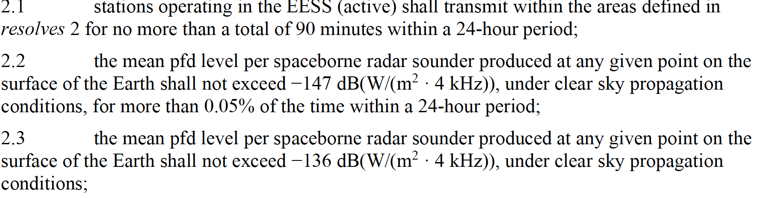

Shown below are the typical operational characteristics of the radar sounder according to Figure A3-1 in Report ITU-R RS.2536 (https://www.itu.int/pub/R-REP-RS.2536-2023)

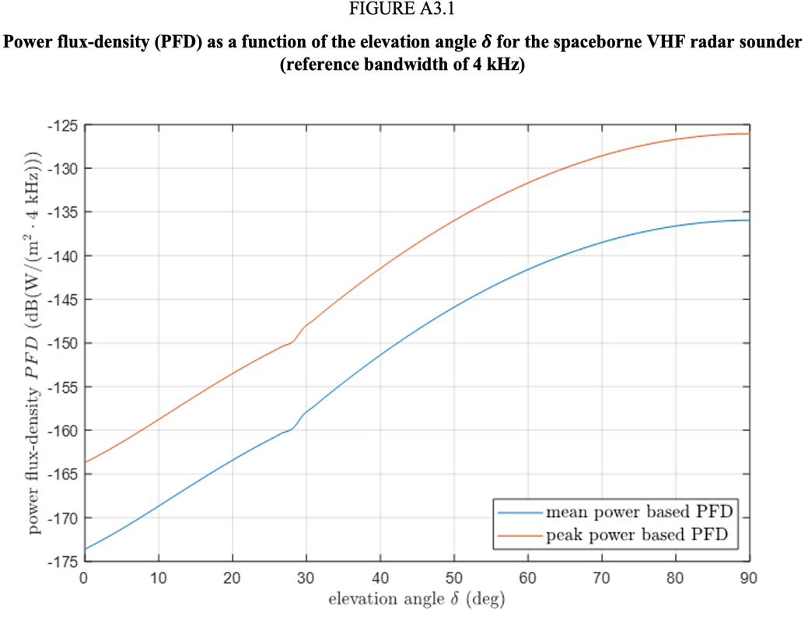

Agenda Item 1.4 to consider, in accordance with Resolution 247 (WRC-19), the use of high-altitude platform stations as IMT base stations (HIBS) in the mobile service in certain
frequency bands below 2.7 GHz already identified for IMT, on a global or regional level;

694/698 – 960 MHz:

Spectrum bands already identified for IMT In this frequency range were also identified for use by HIBS in Regions 1 and 2 and use of HIBS was restricted to uplinks (UE -> HIBS) in spectrum bands whose 2nd harmonics (2x frequency) fall in the RAS bands around 1 413, 1 612, and 1 665 MHz – see new fn 5.14A and Resolution COM4/3 (WRC-23). The ID for HIBS in Region 3 is via a more complex country footnote 5.14B including Australia, China, Korea, Japan and Thailand aka all the countries that do radio astronomy, restricting HIBS use to the uplink direction to protect the RAS bands around 1 413 and 1 665 MHz.

2 500 – 2 700 MHz:

The CPM text’s hard limit on unwanted emissions of HIBS into the RAS band at 2 690 – 2 700 MHz was adopted in Resolution COM4/4 (WRC-23) along with the calendrical ordering of priorities that protects RAS sites registered in the MiFR within 6 months of the conclusion of WRC-23 or before the date of registration of HIBS.

The footnotes and Resolutions containing these gifts to radio astronomy and other impacted services are minor masterpieces of ITU-R sophistry and circumlocution that attempt to redefine both HIBS and HAPS.

For a generation the public has been told to turn off their cell phones while airborne to protect aircraft avionics and to prevent dropped calls on the ground, but now it is OK to put powerful IMT base stations on platforms in the stratosphere that are visible for 600 km in all directions?

Agenda Item 1.11 to consider possible regulatory actions to support the modernization of the Global Maritime Distress and Safety System and the implementation of e-navigation, in accordance with Resolution 361 (Rev.WRC-19);

RAS might have been concerned but there seems to have been no involvement with RAS in Issue C concerning admission of the GSO segment of the Beidou system into the GMDSS in portions of Region 3, using MSS spectrum around the 1 612 MHz OH band allocated to RAS. This Agenda Item undid some of the work by radio astronomers at WRC-19 associated with the admission of the Iridium system into the GMDSS for use by maritime MSS. The range of MMSS spectrum accepted as a safety-of-life service in RR No. 5.368 was extended below 1 621 MHz, down to ~1 614 or ~1 616 MHz. The issue is in abeyance until the Beidou system successfully coordinates with the existing MSS systems operated by Iridium and Globalstar.

Agenda Item 1.2 to consider identification of the frequency bands 3 300-3 400 MHz, 3 600-3 800 MHz, 6 425-7 025 MHz, 7 025-7 125 MHz and 10.0-10.5 GHz for International Mobile Telecommunications (IMT), including possible additional allocations to the mobile service on a primary basis, in accordance with Resolution 245 (WRC-19);

6 GHz:

The frequency bands 6 425 – 7 125 MHz (Region 1) and 7 025 – 7 125 MHz (Region 3) were identified regionally for IMT, along with the frequency band 6 425 – 7 125 identified in a Region 2 country footnote applicable to several countries including Brazil and Mexico. Lack of a frequency allocation to RAS around 6.67 MHz was cited as a reason not to do impact studies on the RAS. That spectrum range is also used by EESS (passive) to baseline some of their observing and use by IMT will force EESS (passive) to seek other spectrum for the same purpose, ie Agenda Item 1.19 (WRC-27). For now, see fn 5.6.A12, 5.6B12 and 5.6C12 and Resolution COM 4/7 (WRC-23).

10 GHz:

The frequency band 10 – 10.5 GHz was considered for a new allocation to the mobile service and identification for use by IMT in Region 2. The US, Canada and Argentina took a strong stand for NOC to protect X-band (9.2 – 10.4 GHz) SAR operation and succeeded to limit the new Region 2 allocation to a country footnote including inter alia Brazil and Mexico. As part of its NOC position, the US was adamant in insisting that no protections should be considered for RAS operating in the spectrum band at 10.68 – 10.7 GHz subject to RR No. 5.340. After a vehement diatribe amounting to a firehose of disinformation and distortion by the US, the protections for RAS in the CPM text or (in weaker form) proposed by Cuba were stripped out for everyone including those administrations in the new Region 2 country fn 5.10B12 citing Resolution COM4/6 (WRC-23).

Agenda Item 1.13 to consider a possible upgrade of the allocation of the frequency band 14.8-15.35 GHz to the space research service, in accordance with Resolution 661 (WRC-19);

SRS was indeed upgraded to primary at 14.8 – 15.35 GHz in piecemeal fashion but kept secondary in the US which was the main proponent and intended beneficiary of the proposed upgrade. The associated country footnote (see below) is one of the weirdest ever promulgated because most of the administrations operating extensively in space did not subscribe to the upgrade to primary. In one interpretation the upgrade was unnecessary; in another, these administrations are under the heavy influence of IMT interests that wish to preserve the ability to identify the frequency band 14.8 – 15.35 GHz for use by IMT under Agenda Item 1.7 (WRC-27).

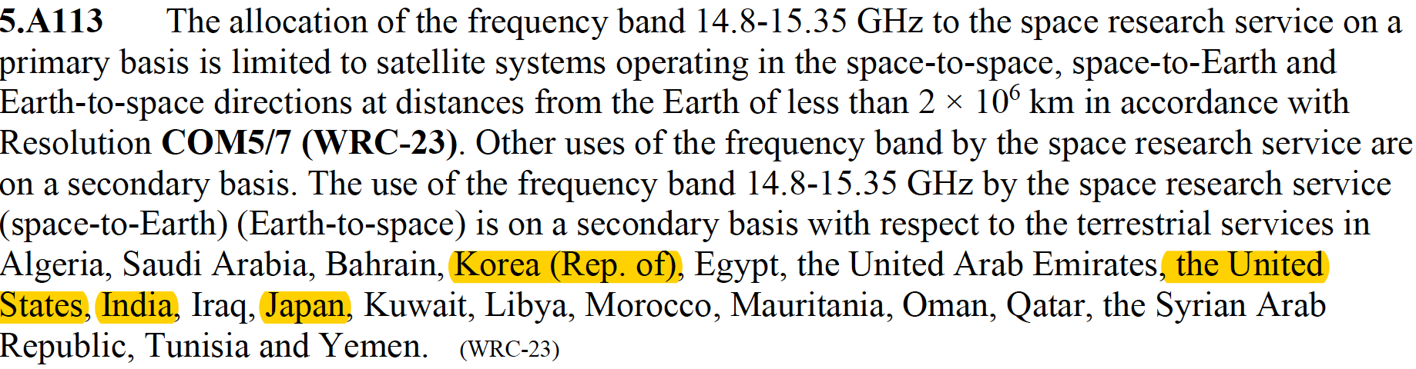

It seems unlikely that the upgrade was sidelined to protect radio astronomy. The protections for radio astronomy in Resolution COM5/7 (WRC-23) give the SRS (where primary) three separate 2% data loss exceptions for different links in the SRS system even though at most one such 2% exception should be considered for the entire SRS system. With these three new exceptions, the RAS frequency band at 15.35 – 15.4 GHz is now subject to four or five different 2% data loss exceptions, depending on how the outcome of Agenda Item 1.10 (WRC-23) is interpreted.

Agenda Item 1.10 to conduct studies on spectrum needs, coexistence with radiocommunication services and regulatory measures for possible new allocations for the aeronautical
mobile service for the use of non-safety aeronautical mobile applications, in accordance with Resolution 430 (WRC-19);

NB: OR -> “off-route” means domestic use and not commercial/international flights. The designation to AMS(OR)S precludes the use of the allocation for so-called internet above the clouds applications that create air-air and air-ground mesh networks for broadband internet. The US is currently taking initial steps toward authorizing such networks in the frequency bands 71-76 and 81-86 GHz that will be very impactful to mm-wave radio astronomy.

This AI suffered from inability of the proponent (Airbus) to demonstrate the need for new spectrum or the amount of new spectrum required to operate the systems being considered.

15.4 – 15.7 GHz: AMS(OR)S received a secondary allocation in Region 1 with a 10 MHz guard band (courtesy of France), but with fn 5.AA110 that weirdly (because AMS(ORS) is secondary) contains language protecting RAS in the adjacent frequency band 15.35 – 15.4 GHz that is subject to RR No. 5.340. A comparable fn 5.A110 was added in Region 3 to apply to Indonesia.

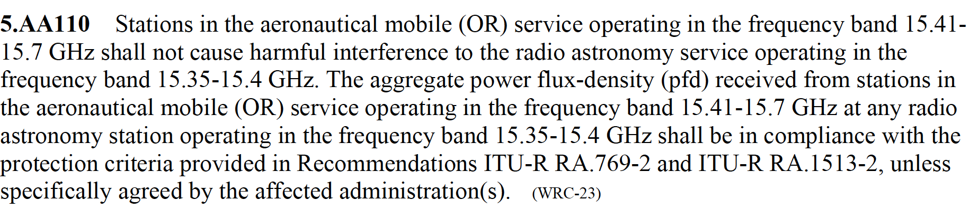

5.AA110 from France replaced a hard limit with no guard band that was included in the CPM text when a primary global allocation to AMS(OR)S was being considered. 5AA110 was removed when the allocation was made secondary, and somehow re-inserted afterward at the insistence of France after discussion seemed to have concluded. The inclusion of 5.AA110 is unusual because secondary allocations are understood to operate on a non-protection, non-interference basis and ITU-R RA.1513 defines a 2% data loss exception that should not be contemplated here and would be a fifth 2% data loss exception applicable to RAS operating in the frequency band 15.35 – 15.4 GHz.

22 – 22.2 GHz: The qualifier “except aeronautical mobile” was lifted for AMS(OR)S in Region 1 in the frequency band 22 – 22.2 GHz, with the addition of five regulatory footnotes (a possible world record) including 5.D110 allowing 2% data loss to RAS operating in the adjacent frequency band at 22.21 – 22.5 GHz. A very long, roughly comparable Region 3 country footnote 5.G110 including Thailand was also created.

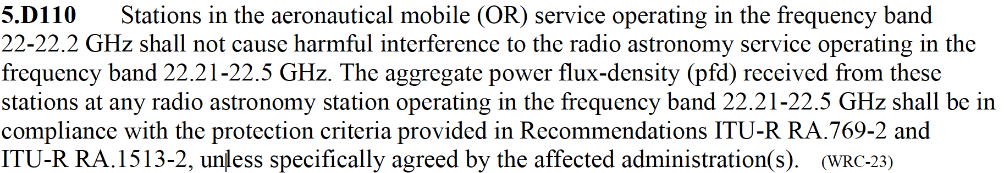

NB: As at the lower frequency, 5.D110 replaced a hard limit with no data loss exception in the CPM text. Replacing a hard limit with regulatory text like 5.D110 suffers from several problems: it does not direct operators to the relevant parts of RA.769 and it allows for the gradual accumulation of an arbitrary number of uncoordinated 2% data loss exceptions.

This Agenda Item gave rise to one of the more unpleasant moments of the WRC when the evil spirit of some ancient Egyptian mummy rose from the grave to speak against inclusion of an innocuous footnote championed by France, noting the possible impact of the new AMS(OR)S allocation on the operation of water vapor radiometers operating without frequency allocations in nearby spectrum. Egypt, reading from a script prepared by Motorola, denounced France’s fn and succeeded in stripping all useful context while relegating the matter to a backwater document where other similar concerns about harmful effects on passive services have historically been warehoused. The US intervened using an arcane mechanism to preserve a reference to the location of the deleted material in the recorded outcome of the WRC, a gracious gesture.

Notes on other Agenda Items:

Agenda Item 1.6 to consider, in accordance with Resolution 772 (WRC-19), regulatory provisions to facilitate radiocommunications for sub-orbital vehicles:

AI 1.6 failed without issue owing to inflexibilities in the Radio Regulations regarding the distinction between terrestrial and space radiocommunication.

Agenda Item 1.8 to consider, on the basis of ITU-R studies in accordance with Resolution 171 (WRC-19), appropriate regulatory actions, with a view to reviewing and, if necessary, revising Resolution 155 (Rev.WRC-19) and No. 5.484B to accommodate the use of fixed-satellite service (FSS) networks by control and non-payload communications of unmanned aircraft systems;

AI 1.8 failed to produce regulatory text at a third successive WRC and was suppressed but may be reconsidered at WRC-31. ICAO moved heaven and earth and bent over backwards to craft SARPS allowing UAV to operate under the conditions defined at ITU-R during WRC-19, but its work was repudiated and thrown into the wastebin at WRC-23 owing to ITU-R’s own internal hostilities over the proposed operation. This was a disaster once again temporarily averted for RAS given earlier studies at WRC-12 showing interference at levels 120 dB above RA. 769.

Agenda Item 1.14 to review and consider possible adjustments of the existing or possible new primary frequency allocations to EESS (passive) in the frequency range 231.5-252 GHz,
to ensure alignment with more up-to-date remote-sensing observation requirements, in accordance with Resolution 662 (WRC-19);

EESS (passive) succeeded in its quest for new spectrum to accommodate the operating range of its recent sensors, by trading with fixed service so that FS gained access to an appreciably greater amount of λ1.3mm spectrum formerly used by EESS (passive). However, this only happened despite the best efforts of the US to forestall the needed adjustments to the table of frequency allocations. The US seems to want to preserve the ability of radiolocation systems to operate under AI 1.8 (WRC-27) in/near the spectrum now allocated to EESS (passive). At one point, the US tried to insert language demanding that EESS (passive) protect radiolocation operations, an absurd requirement on a passive service, loosely implying that EESS (passive) should not operate. Lacking any support, the shape-shifting US position was eventually understood to be so fatuous that a little-used rule shutting down debate was invoked to bring the matter to its eventual successful conclusion.

Documents not available as ITU-R Reports or Recommendations (TIES access needed)

AI 1.4 in the WP 5D document archives:

For HIBS characteristics: see
[ 1668 ]  +Ch.1-7 | Report on the 43rd meeting of Working Party 5D (Geneva, 31 January - 9 February 2023)

Especially
Word | 274517 bytes | 2023-02-15 | [1668] Chapter 4 - Annex 4.10 - [Working document towards a] Preliminary draft new Report ITU-R M.[HIBS-CHARACTERISTICS]

For HIBS sharing and compatibility studies: see
[ 1555 ]  +Ch.1-7 | Report on the 42nd meeting of Working Party 5D (Geneva , 10-21 October 2022)

Especially
Word | 11191004 bytes | 2022-11-04 | [1555] Chapter 4 - Annex 4.32 - Annex 1 - Sharing and compatibility studies of high-altitude platform stations as IMT base stations (HIBS) in the 694-960 MHz frequency range
Word | 20918032 bytes | 2022-11-04 | [1555] Chapter 4 - Annex 4.35 - Annex 4 - Sharing and compatibility studies of high-altitude platform stations as IMT base stations (HIBS) in 2 500-2 690 MHz frequency range

AI 1.2 See:
1776 ]  +Ch.1-7 | Report on the 44th meeting of Working Party 5D (Geneva, 12-22 June 2023)

Especially for 10 GHz
Word | 47666 bytes | 2023-07-07 | [1776] Chapter 4 - Annex 4.19 - Supporting material for WRC-23 agenda item 1.2 - Sharing and compatibility studies of IMT systems in the frequency band 10-10.5 GHz in Region 2 - Main Part
Word | 1822806 bytes | 2023-07-10 | [1776] Chapter 4 - Annex 4.24 - Supporting material for WRC-23 agenda item 1.2 - Sharing and compatibility studies of IMT systems in the frequency band 10-10.5 GHz in Region 2 - Attachment 5 - Compatibility of RAS and IMT operating in the frequency band 10-10.5 GHz

AI 1.13 see
[ 277 ]  +Ann.1-9 | Report of the meeting of Working Party 7B (Geneva, 3-10 October 2023)

Especially
Word | 18559062 bytes | 2023-10-12 | [277] Annex 1 - Preliminary draft new Report ITU-R SA.[15 GHZ SRS SHARING] - Sharing and compatibility studies for the SRS in the band 14.8-15.35 GHz

AI 1.10 See
[ 819 ]  +Ann.1-21 | Report on the thirty-first meeting of Working Party 5B (Geneva, 10-21 July 2023)

Especially for RAS
Word | 5738864 bytes | 2023-08-16 | [819] Annex 15 - Annex 7 - Compatibility studies between future systems operating in the non-safety aeronautical mobile (off-route) service planned to operate in frequency bands 15.4-15.7 GHz and 22-22.21 GHz and radioastronomy stations operating in 15.35-15.4 GHz and 22.21-22.5 GHz

