Agenda Items 1.n listed in order of item index (*=WP 7D contributing, **=WP 7D responsible)

  - *to consider the technical and operational conditions for the use of the frequency bands 47.2-50.2 GHz and 50.4-51.4 GHz (Earth-to-space), or parts thereof, by aeronautical and maritime earth stations in motion communicating with space stations in the fixed-satellite service and develop regulatory measures, as appropriate, to facilitate the use of the frequency bands 47.2-50.2 GHz and 50.4-51.4 GHz (Earth-to-space), or parts thereof, by aeronautical and maritime earth stations in motion communicating with geostationary space stations and non-geostationary space stations in the fixed-satellite service, in accordance with Resolution 176 (Rev.WRC-23);

  - to consider possible revisions of sharing conditions in the frequency band 13.75-14 GHz to allow the use of uplink fixed-satellite service earth stations with smaller antenna sizes, in accordance with Resolution COM6/1 (WRC-23);

  - *to consider studies relating to the use of the frequency band 51.4-52.4 GHz to enable use by gateway earth stations transmitting to non-geostationary-satellite orbit systems in the fixed-satellite service (Earth-to-space), in accordance with Resolution COM6/3 (WRC-23);

  - to consider a possible new primary allocation to the fixed-satellite service (space-to-Earth) in the frequency band 17.3-17.7 GHz and a possible new primary allocation to the broadcasting-satellite service (space-to-Earth) in the frequency band 17.3-17.8 GHz in Region 3, while ensuring the protection of existing primary allocations in the same and adjacent frequency bands, and to consider equivalent power flux-density limits to be applied in Regions 1 and 3 to non-geostationary-satellite systems in the fixed-satellite service (space-to-Earth) in the frequency band 17.3-17.7 GHz, in accordance with Resolution COM6/24 (WRC-23);

  - to consider regulatory measures, and implementability thereof, to limit the unauthorized operations of non-geostationary-satellite orbit earth stations in the fixed-satellite and mobile-satellite services and associated issues related to the service area of non-geostationary-satellite orbit satellite systems in the fixed-satellite and mobile-satellite services, in accordance with Resolution COM6/6 (WRC-23);

  - *to consider technical and regulatory measures for fixed-satellite service satellite networks/systems in the frequency bands 37.5-42.5 GHz (space-to-Earth), 42.5-43.5 GHz (Earth-to-space), 47.2-50.2 GHz (Earth-to-space) and 50.4-51.4 GHz (Earth-to-space) for equitable access to these frequency bands, in accordance with Resolution COM6/7 (WRC-23);

  - *to consider studies on sharing and compatibility and develop technical conditions for the use of International Mobile Telecommunications (IMT) in the frequency bands 4 400-4 800 MHz, 7 125-8 400 MHz (or parts thereof), and 14.8-15.35 GHz taking into account existing primar services operating in these, and adjacent, frequency bands, in accordance with Resolution COM6/26 (WRC-23);

  - *to consider possible additional spectrum allocations to the radiolocation service on a primary basis in the frequency range 231.5-275 GHz and possible new identifications for radiolocation service applications in the frequency bands within the frequency range 275-700 GHz for millimetric and sub-millimetric wave imaging systems, in accordance with Resolution 663 (Rev.WRC-23);

  - to consider appropriate regulatory actions to update Appendix 26 to the Radio Regulations in support of aeronautical mobile (OR) high frequency modernization, in accordance with Resolution COM6/2 (WRC-23);

  - *to consider developing power flux-density and equivalent isotropically radiated power limits for inclusion in Article 21 of the Radio Regulations for the fixed-satellite, mobile-satellite and broadcasting-satellite services to protect the fixed and mobile services in the frequency bands 71-76 GHz and 81-86 GHz, in accordance with Resolution 775 (Rev.WRC-23);

  - *to consider the technical and operational issues, and regulatory provisions, for space-to-space links among non-geostationary and geostationary satellites in the frequency bands 1 518-1 544 MHz, 1 545-1 559 MHz, 1 610-1 645.5 MHz, 1 646.5-1 660 MHz, 1 670-1 675 MHz and 2 483.5-2 500 MHz allocated to the mobile-satellite service, in accordance with Resolution 249 (Rev.WRC-23);

  - *to consider, based on the results of studies, possible allocations to the mobile-satellite service and possible regulatory actions in the frequency bands 1 427-1 432 MHz (space-to-Earth), 1 645.5-1 646.5 MHz (space-to-Earth) (Earth-to-space), 1 880-1 920 MHz (space-to-Earth) (Earth-to-space) and 2 010-2 025 MHz (space-to-Earth) (Earth-to-space) required for the future development of low-data-rate non-geostationary mobile-satellite systems, in accordance with Resolution COM6/8 (WRC-23);

  - *to consider studies on possible new allocations to the mobile-satellite service for direct connectivity between space stations and International Mobile Telecommunications (IMT) user equipment to complement terrestrial IMT network coverage, in accordance with Resolution COM6/9 (WRC-23);

  - to consider possible additional allocations to the mobile-satellite service, in accordance with Resolution COM6/10 (WRC-23);

  - *to consider studies on frequency-related matters, including possible new or modified space research service (space-to-space) allocations, for future development of communications on the lunar surface and between lunar orbit and the lunar surface, in accordance with Resolution COM6/4 (WRC-23);

  - **to consider studies on the technical and regulatory provisions necessary to protect radio astronomy operating in specific Radio Quiet Zones and, in frequency bands allocated to the radio astronomy service on a primary basis globally, from aggregate radio-frequency interference caused by non-geostationary-satellite orbit systems, in accordance with Resolution COM6/11 (WRC-23);

  - *to consider regulatory provisions for receive-only space weather sensors and their protection in the Radio Regulations, taking into account the results of ITU Radiocommunication Sector studies, in accordance with Resolution COM6/12 (WRC-23);

  - **to consider, based on the results of ITU Radiocommunication Sector studies, possible regulatory measures regarding the protection of the Earth exploration-satellite service (passive) and the radio astronomy service in certain frequency bands above 76 GHz from unwanted emissions of active services, in accordance with Resolution COM6/5 (WRC-23);

  - to consider possible primary allocations in all Regions to the Earth exploration-satellite service (passive) in the frequency bands 4 200-4 400 MHz and 8 400-8 500 MHz, in accordance with Resolution COM4/8 (WRC-23);

Agenda Items 1.n listed in order of responsible Working Party:

WP 4A
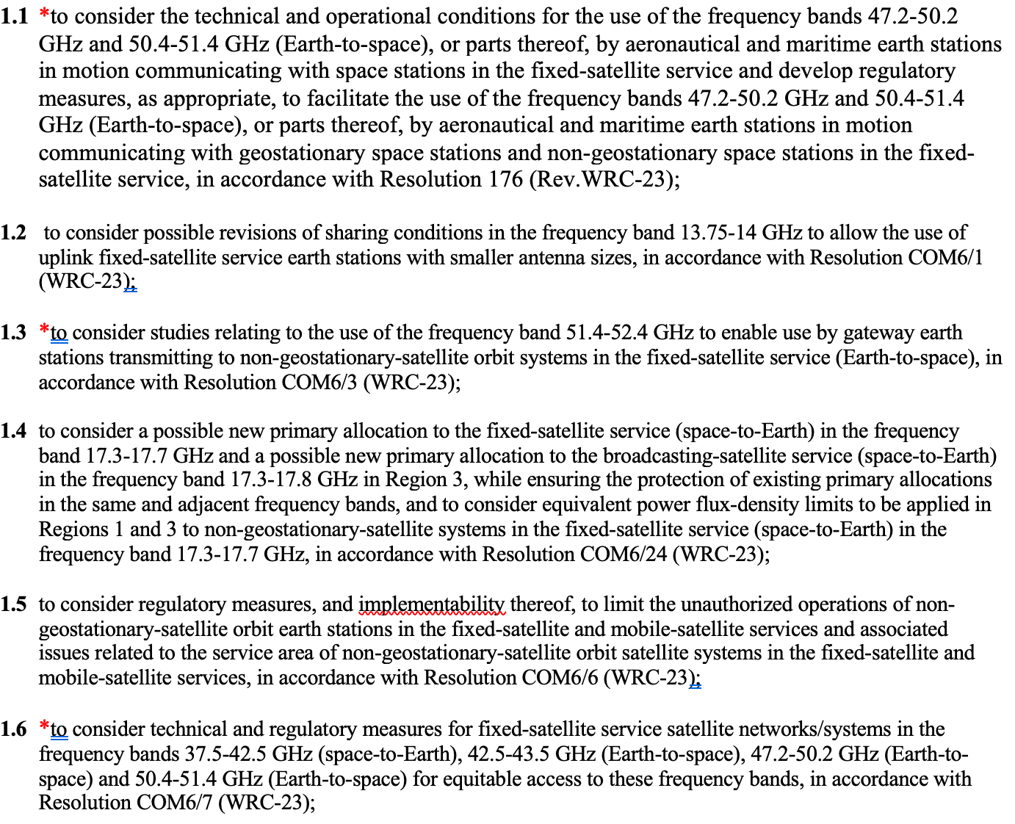
WP 4C
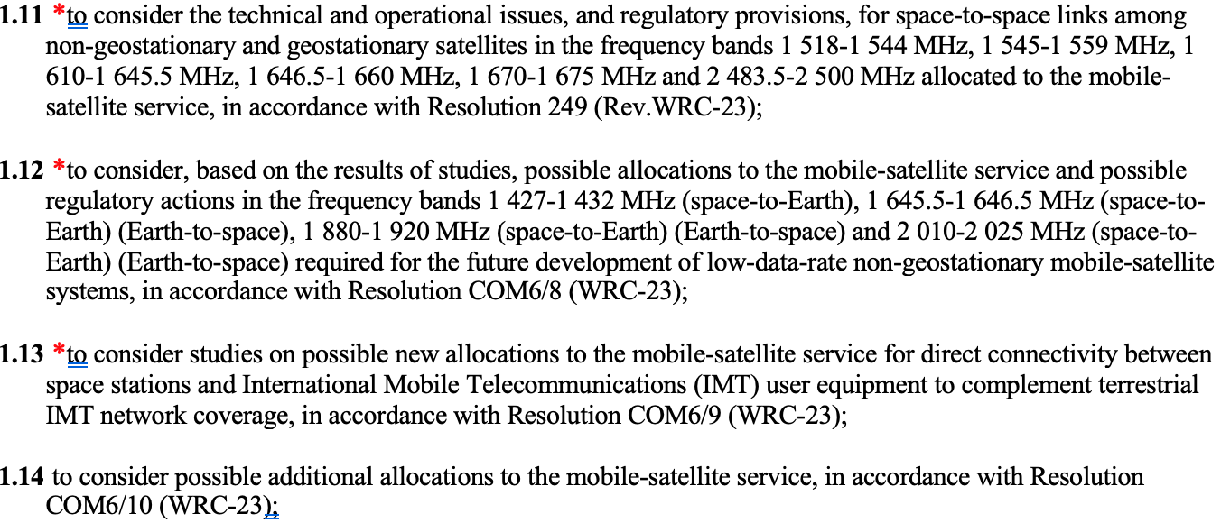

WP 5B
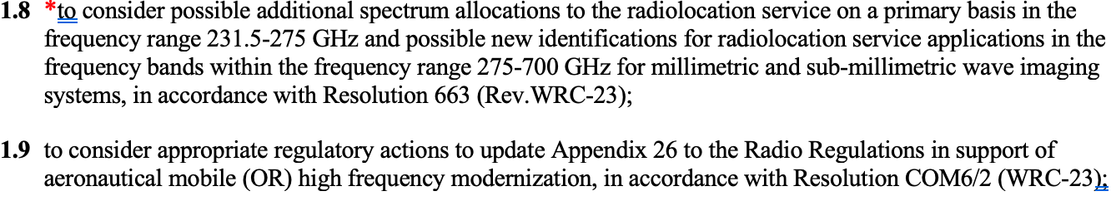
WP 5C
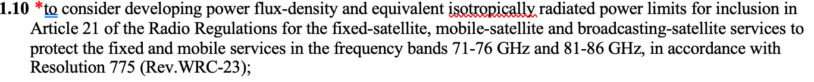
WP 5D
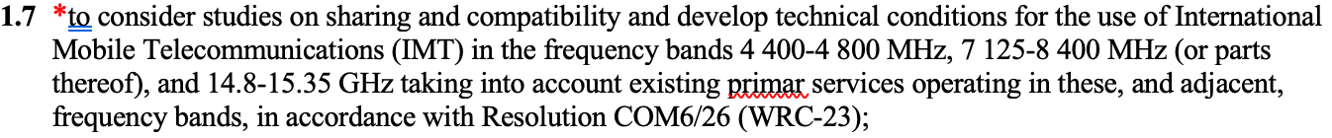
WP 7B
WP 7C
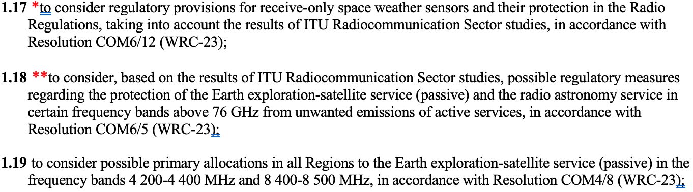
WP 7D
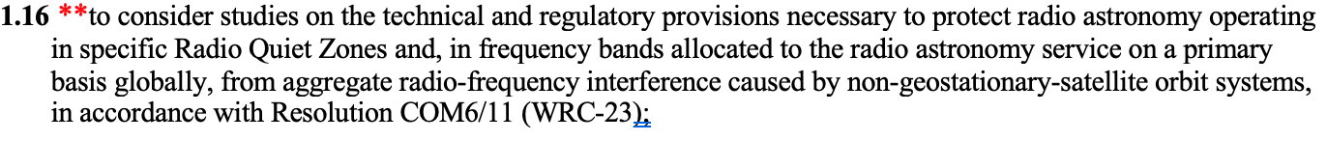

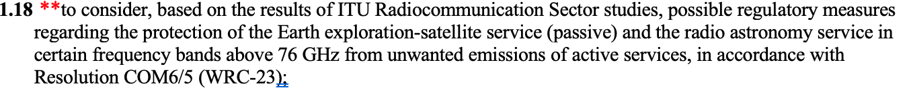

Order of work for WRC-related items during the upcoming cycle

- Two items for which WP 7D is responsible.
  - 1.16 Protection from satellite RFI above 10.7 GHz
  - 1.18 Rev. of Res. 739, protection of RAS from satellites in other bands
- Two items involving satellite direct-cell in adjacent bands
  - 1.12 MSS (s-E) 1 427 -1 432 MHz
  - 1.13 MSS (s-E) in IMT bands 694/698 – 2 700 MHz
- Items requiring study to prevent RFI to RAS from adjacent bands
  - 1.1 Protect CS J=1-0 from airborne ESIM operating in FSS bands
  - 1.7 Potential IMT identification at 14.8 – 15.35 GHz
  - 1.8 Allocation/identification for radiolocation 231.5 – 275/275 – 700 GHz
  - 1.10 Revision of Art. 21 limits for FSS, MSS, BSS 71 – 76 & 81 – 86 GHz
  - 1.11 Intersatellite links in MSS bands at/around OH 1 612, 1 665/1 667 MHz
- Items requiring attention and perhaps study
  - 1.15 Allocations to space operations service for lunar radiocommunications
  - 1.17 Protection of receive-only space weather sensors
  - 1.6 “Equitable access” for FSS operations at ~37 – 50 GHz

