Transport from Adolfo Suarez-Barajas Madrid Airport to Alcalá de Henares City Centre
BY BUS:
- Direct bus Line 824 connects Terminal T1 and T2 of Madrid-Barajas Airport with Alcalá de Henares. RECOMMENDED option, https://goo.gl/maps/8V4zHi7zVsMmwzhS6
Stops at the airport:
Terminal T1. Floor 0. Arrivals
Terminal T1. Floor 1. Departures
Terminal T2. Floor 0. Arrivals
Terminal T2. Floor 2. Departures
In order to get from one terminal to another (T1, T2, T3, T4), passengers and visitors can use a free bus transport service between the airport terminals, 24 hours a day.
Schedule and contact. From 6:00 am to 11:25 pm. Phone: +34 915 804 540
- Interurban line from Airport to Madrid (Avda. De América) and then bus Madrid – Alcalá de Henares:
Line 223. Madrid (Avda. de América) – Alcalá de Henares. RECOMMENDED option, https://goo.gl/maps/9Rs9ie5YctvHmEcc8
Line 227. Madrid (Avda. de América) – Alcalá de Henares (Espartales-Universidad). NO STOPS IN THE CITY CENTRE, https://goo.gl/maps/LNnWCLgt6oDCtvuk9
Line 229. Madrid (Avda. de América) – Alcalá de Henares (Virgen del Val). NO STOPS IN THE CITY CENTRE, https://goo.gl/maps/aq7FgFJv5zsCVNMP6
Night Line N202. Madrid (Avda. de América) – Torrejón de Ardoz – Alcalá de Henares. (Night service line), https://goo.gl/maps/QgwDRrtwQist5emE7
More information: ALSA. Avda. de América, 9A. Tel. 902 42 22 42, Interchange of Avda. de América 28002. Madrid. Website: http://www.alsa.es
BY TRAIN:
MADRID CERCANÍAS RENFE (Suburban Train). From Madrid to Alcalá you can also go by train. Main stops in Madrid are Chamartin and Atocha.
From Atocha to Alcalá: https://goo.gl/maps/C7Xt6fFWYdxtA92L9
From Chamartin to Alcalá: https://goo.gl/maps/vhEqGP6uUW7He7PH8
More information about stops and tickets are provided in the links:
Line C2: Chamartín - Atocha - Alcalá de Henares – Guadalajara (https://www.redtransporte.com/madrid/cercanias-renfe/linea-c-2.html)
Line C7: P. Pío - Chamartín - Atocha - Alcalá de Henares (https://www.redtransporte.com/madrid/cercanias-renfe/linea-c-7.html)
BY TAXI:
- Taxis are always available at the airport.
- If you need to book a taxi from Alcalá to the airport:
Radio Taxi Phone Numbers. +34 91 882 21 88; +34 91 882 21 79
CC. Los Pinos, shops 30-31. www.alcalaradiotaxi.com
- Uber and Cabify are also available in Madrid area.

Transport from Alcalá de Henares City centre to the Venue
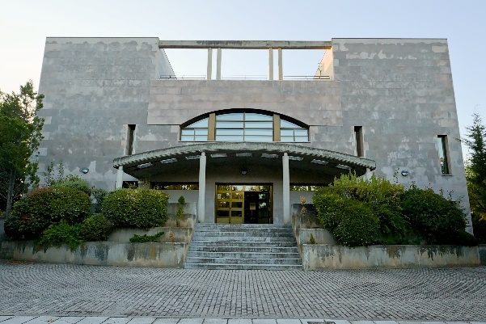
Date / Time: Sept. 29-Oct 3, 2025.
Venue: Centro de Investigaciones de Ciencias Geográficas y Astronomía. Observatorio Astronómico Nacional.
Address: C. Escultor Claudio, 6A, 28805 Alcalá de Henares, Madrid.
Transport to the venue: As the venue is located far from the city center, a bus will be provided every day from the city centre to the venue. TBC.
The exact meeting point for the bus will be published soon but it will be close to the monument “Puerta de Madrid” (https://goo.gl/maps/5maF9Hubuw6GAyz18). In that area, several recommended hotels are located.

